Name: Astha Arpit Bhatt

Enroll: 196140316006

Practical-6

Aim: Develop an applet that uses the mouse listener, which overrides only two methods which are mousePressed and mouseReleased

Code:

import java.applet.\*;

import java.awt.\*;

import java.awt.event.\*;

/\*<applet code="pra6" height=500 width=500></applet>\*/

public class pra6 extends Applet implements MouseListener

{

static String msg;

public void init()

{

addMouseListener(this);

}

public void paint(Graphics g)

{

g.drawString(msg,10,10);

}

public void mousePressed(MouseEvent me)

{

msg="Mouse Pressed";

repaint();

}

public void mouseReleased(MouseEvent me)

{

msg="Mouse Released";

repaint();

}

public void mouseExited(MouseEvent me)

{

}

public void mouseEntered(MouseEvent me)

{

}

public void mouseClicked(MouseEvent me)

{

}

}

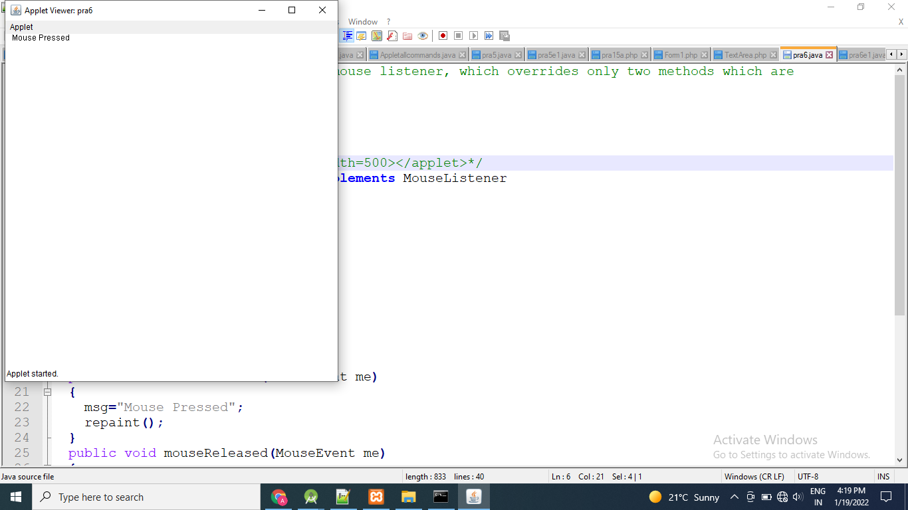

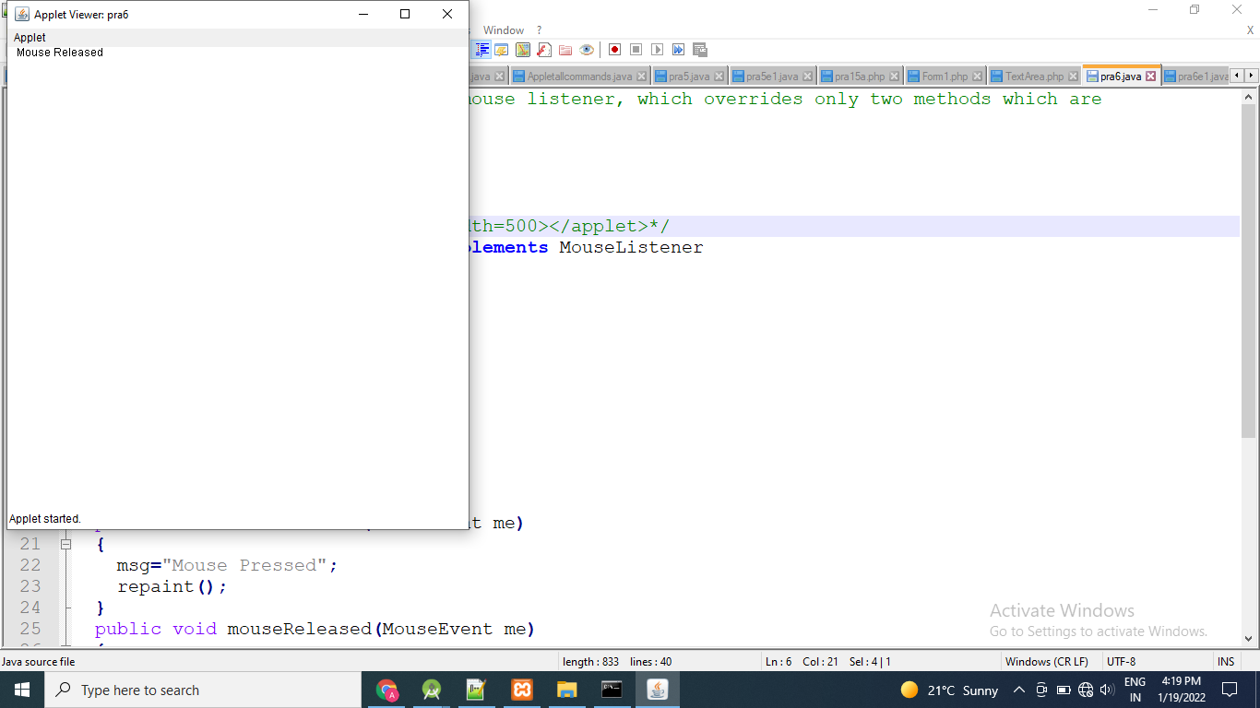

Exercise:

Write a java program to handle, mouse motion listener events.

import java.applet.\*;

import java.awt.\*;

import java.awt.event.\*;

/\*<applet code="pra6e1" height=500 width=500></applet>\*/

public class pra6e1 extends Applet implements MouseMotionListener

{

static String msg;

public void init()

{

addMouseMotionListener(this);

}

public void paint(Graphics g)

{

g.drawString(msg,10,10);

}

public void mouseDragged(MouseEvent e)

{

msg="Mouse Dragged";

repaint();

}

public void mouseMoved(MouseEvent e)

{

msg="Mouse Moved";

repaint();

}

}

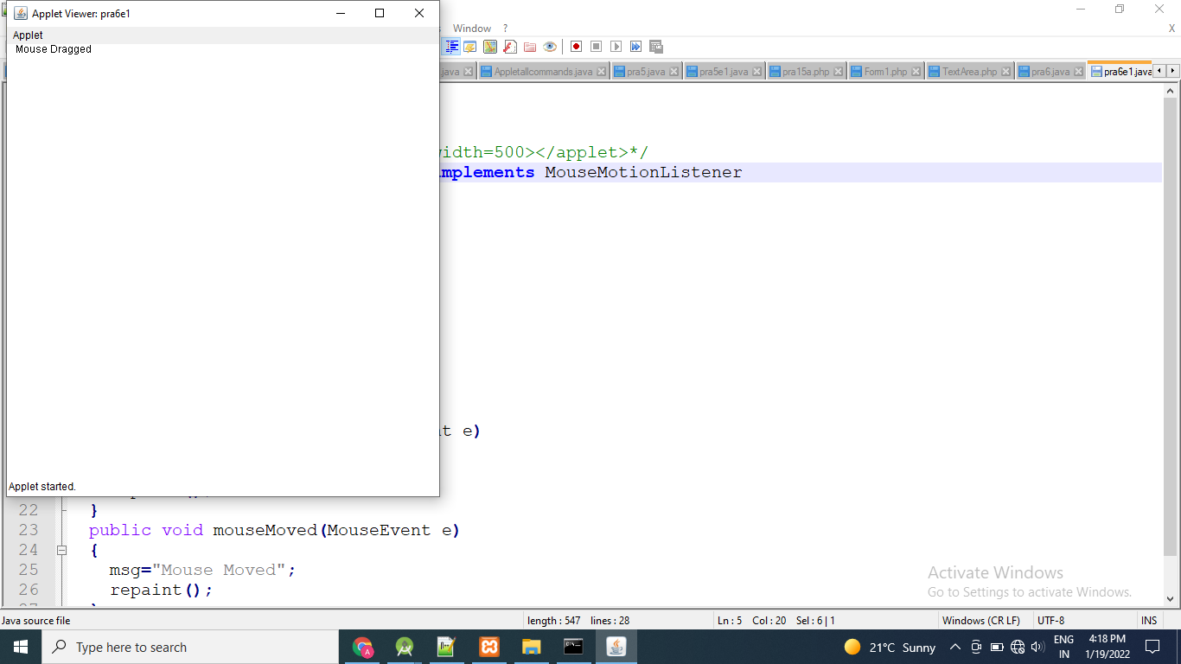

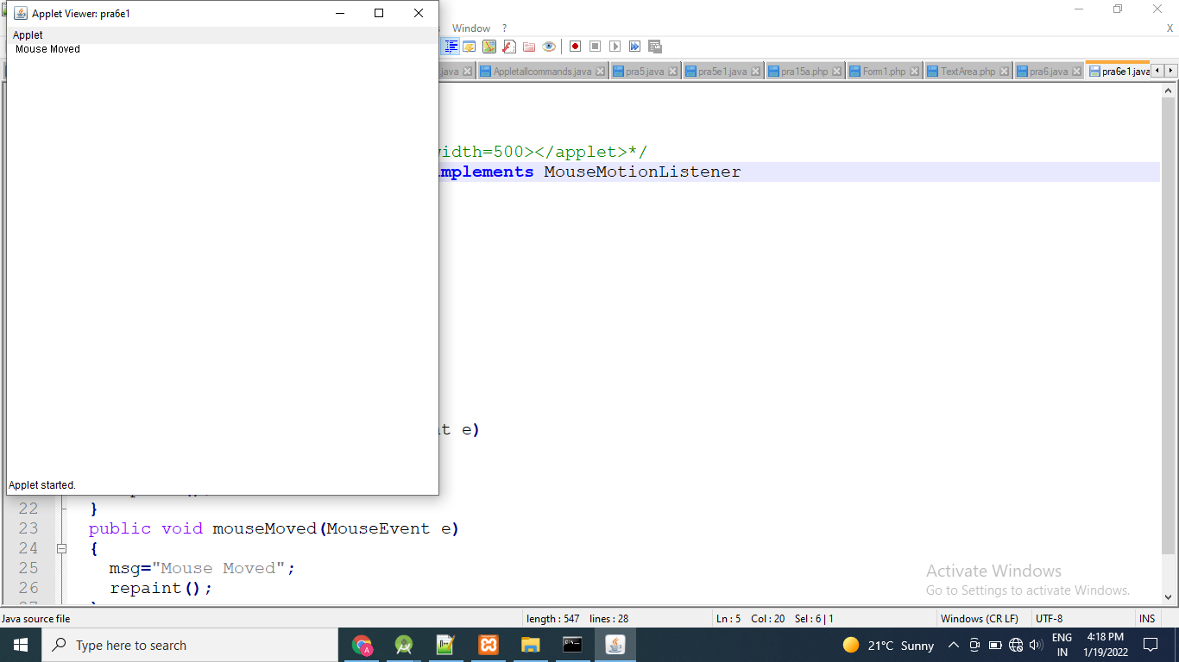

Thanks mam!!